
Global Roundtable
Our shared goal:
To establish an effective disciple-making, church planting roundtable in each nation, supported by regional collaborative gatherings.
https://collaborate2saturate.org/about-us/
Around one key question:
“What will it take to saturate our nation with the gospel through church multiplication?”
Fri August 8, 2025 (9 am – 10:30 am Eastern, 13:00 UTC) Other time zones HERE.
Meeting link: https://us02web.zoom.us/j/6328187504
Agenda
Time (Eastern) | Topic | Comment/Discussion | Notes / Decisions / Actions
9:00 | Preparation of heart | Welcome, introduction of guests, checking-in, Word and Prayer
9:10 | Agenda review, inviting additions | June meeting summary for friends / notes for members (Posted to C2S website, scroll down.)
9:15 | Regional Focus: Africa postponed to Sept 19 (S & E Africa annual conference Aug 7-8)  East Asia | - Update from the region  - Discussion and encouragement  - How can we help?  - Prayer  Thoughts on potential regional team members?
9:15 | Dashboard | Let’s review our map overview page – is there anything you know to add? Gathering, leaders?
9:25 | Core team Shepherds – supporting regional clusters (applying Jethro’s wisdom) | - Previous meeting: agreement in principle.  - Today: practical application including who will support which clusters.
9:40 | Set dates for our core team  - annual in-person meeting in Malta,  - meeting with regional leaders (MENA only?)  Factors:  - Blue Med meets Feb 23 (7 pm) to Feb 27 (evening) 2026.  - Internal poll, next column. (If you’ve not yet voted, go to WhatsApp post for July 10) | 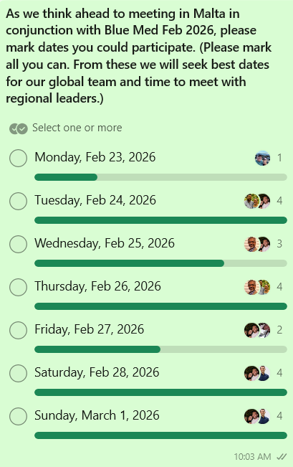
9:50 | Asia Forum: Nov 4-7 in Chaing Mai anticipating 500 participants | KR: Who of us plans to attend and could help staff our C2S display booth?  What else could we do or distribute for maximum impact?  E.g. propose pre reading for registrants from C2S’s Call to Collaborate
10:00 | Learning Communities | For National Coordinators:  Date: Monday October 13, 2025  Topic:  Planning Team:  For Regional Teams:  Date to plan quarterly “learning community” proposed: Tuesday Aug 26 (9:00 Eastern / 13:00 UTC)
10:15 | Other updates from and since previous meeting  New Business / Round Robin / Next Agenda | Bruce: update on the Motus Dei statement: “Reactivating the Church as Movement”.
10:25 | Calendar:  Core team (zoom):  - Sept 19 - regional focus: Africa?  - Oct 31  - Dec 12/25  - Jan 23/26  Core team (in-person):  Blue Med Venue: https://axhotelsmalta.com/odycy/about-qawra-hotel  Costs: $75-85 per day double occupancy with option to join as many days as desired. Cost commensurate. | C2S admin/ad hoc exec team - to help stay focused on Honduras action items: Monday Aug 18 (11:00 Eastern)
10:30 | Prayer

(End of Agenda)
______________________________
For Reference:
Contacts & Links:
- C2S Roundtable – Global Core Team: we aim for participation of two members of each organization in our 6 wk meetings, ideally one non-western:
GACX: https://gacx.io  Joey Shaw: joey.shaw@gacx.io  +34 662 36 88 66  delegated to:  Rick Fiechter: rick.fiechter@gacx.io  WhatsApp: 407-744-7007  KR Green: kr.green@gacx.io  +1 (714) 308-5401 | Lausanne: https://churchplanting.lausanne.org  John Wagenveld: jwagenveld@gmail.com  Cruz Paniagua  cruzmpaniagua@gmail.com  Ron Anderson: ron.ecmi@gmail.com | Vision 5:9: www.fruitfulpractice.org  Ryan Emis: ryan.emis@vianations.org  Martin Hall :  martin.hall@vision59.com  (Ministry leadership rotation in process)
GCPN: www.gcpn.info  Karl Teichert: karlteichert@oci.org  Beto Morales:  amorales@reddemultiplicacion.com | FFT: https://finishingthetask.com  Lisa Pak: lisa@finishingthetask.com  Kyle Henderson kyle@finishingthetask.com | COTW: https://cotw.global  JJ Alderman (TT): jj.alderman@COTW.global  Andrew Adudu (E3P): andrew.adudu@e3partners.org 816-699-3001  (cc: exec assistants:  daniellefoltz@ttionline.org samanthamcdaniel@ttionline.org
24 :14:
Cruz will check on interest during 24:14 Latin America conference in June
Murray will check with Dan Hitzhusen

- C2S Regional teams: Additional detail and on-line edits HERE
Africa (Eng, Port, Spanish):  Horn of Africa:  *Tariku Kersima tariku.fre@gmail.com  Elias Negeri negeri.elias@gmail.com  Southern Cone:  Karl Teichert  karlteichert@oci.org  Africa (Francophone):  Boureima Diallo  boureima@fulnet.org  Caribbean:  *israespinal@gmail.com;  avallellanes@usa.com  Central & South America:  amorales@reddemultiplicacion.com  cruzmpaniagua@gmail.com  Europe:  *Christian Kuhn  chrikuhn@gmail.com  Eurasia/Central Asia:  *Ruslan Zagidulin rzagidulin@lausanne.org  Mark Hirst mark.hirst@willesboroughbaptist.church  * Team leader | MENA (North Africa/Middle East):  *Mourad Rouibet (NA):  drmrouibet@gmail.com  *Michael el Daba (ME):  eldaba@gmail.com  Adam Youcef: adam789@protonmail.com  South East Asia:  Warren Laurence  warrenl@worksmail.net  Judah Cantoria  judahjim1@yahoo.com  Irwan Widjaja irwanwidjaja.fiw@gmail.com  East Asia:  *haramdle@gmail.com  South Asia (outside India):  Chris Gnanan  chrisgnanakan@gmail.com  Kris Ramsundar  kramsundar@multiplicationnetwork.org | India:  *Rajesh Malaki rajeshmalaki@gmail.com  Alex Abraham alexldh@protonmail.com  Sheriff Daniel sheriff@meshaindia.org  Bro. Harish: harish8733173@gmail.com  Charlie Abro: charlieabro@gmail.com  North America:  Emerging team:  - bruce.wilson@asburyseminary.edu  - Ron Anderson, Matt Fretwell  - Amplify conference  - One Challenge International  Oceania:  *Bill Hodgson:  bill.hodgson@powertochange.org.au  Conrad Parsons: conrad.parsons@yfci.org  Chris Swann: chris@citytocityaustralia.org.au
- C2S Team Leaders and Functions:
Back-office support: admin assistance, website and communications. | Dulcie dcrawford@multiplicationnetwork.org Kris kramsundar@multiplicationnetwork.org
Admin/exec - review to help stay focused on Honduras action items. | Ad hoc (between 6 wk mtgs)
Dashboard: access and training | David Piccinelli
National Facilitators: (quarterly) Learning Community | Ron Anderson, Murray Moerman, Kris Ramsundar, Chris Gnanakan
Regional teams: support & development | Regional shepherds
Prayer: Movement Training | Tety Irwan tetyirwan@yahoo.com

Other links …
C2S Foundational Documents: https://collaborate2saturate.org/c2s-foundations | Upload Reports on collaboration events: https://forms.gle/RX3uKzRV97Z1N3M17 | Prayer: Thursdays (13:30 UTC) https://chat.whatsapp.com/L7QWC9fnLP1C0En2irqLuJ
Resource Toolbox:  - for effective collaboration  - tools for effective CP/DMM | Contribute onto this “staging area”: https://docs.google.com/document/d/1xIqVgVAPOegxfoVZ8g9tkxlG_wwyEuZFoF19HlE7_Nk/edit?tab=t.0 | C2S shared google drive: HERE  Learning Community: https://www.youtube.com/@collaborate2saturate/videos

